Project Design Phase-II
Data Flow Diagram & User Stories

Date | 7 November 2025
Team ID | NM2025TMID09184
Project Name | Laptop Request Catalog Item
Maximum Marks | 4 Marks

Data Flow Diagrams:
A Data Flow Diagram (DFD) is a traditional visual representation of the information flows within a system. A neat and clear DFD can depict the right amount of the system requirement graphically. It shows how data enters and leaves the system, what changes the information, and where data is stored.
In the project “Laptop Request Catalog Item”, Data Flow Diagrams (DFDs) illustrate how laptop request submissions are processed within the
ServiceNow system. The DFD shows the interaction between the employee (requester), the ServiceNow platform, and the IT department or approver to ensure a smooth and automated request workflow. When an employee submits a laptop request form through the Service Catalog, the system captures key details such as the laptop model, justification, and additional accessories. If the employee selects the “Additional Accessories” checkbox, the form dynamically displays the “Accessories Details” field, which becomes mandatory through a UI Policy.
The system validates all inputs before forwarding the request to the IT department for review and approval. Additionally, a “Reset Form” UI action allows users to clear all entered details instantly, improving usability. Once the configuration is complete, the update set is exported and committed to another instance, ensuring version control and deployment consistency. This DFD effectively represents how user input, system logic, and administrative controls interact to streamline and automate the laptop request process.

Example:

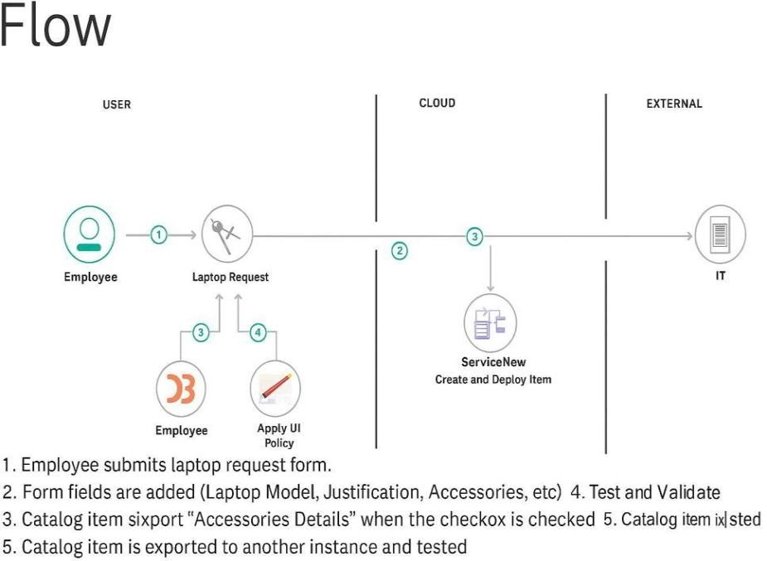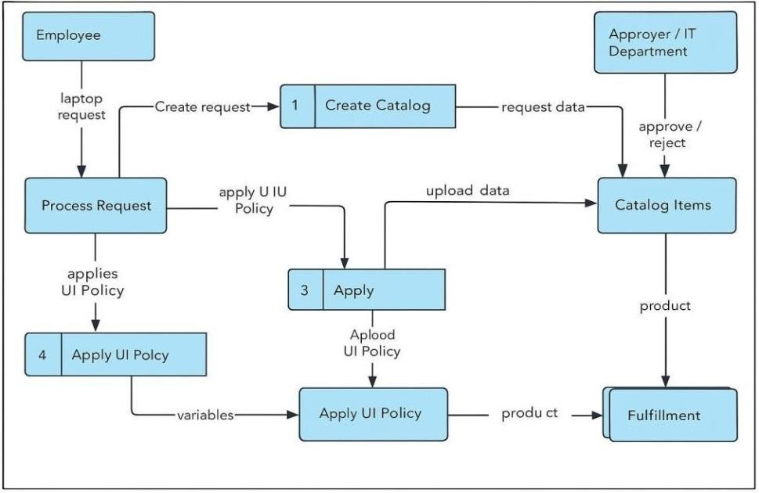

User Stories
User stories define what different users need from the system in simple, goal-focused language.In this project, they help ensure employees can efficiently request laptops, the system dynamically responds to user selections, and administrators can manage and deploy the catalog item smoothly.

User Type | Functional  Requirement  (Epic) | User Story No. | User Story / Task | Acceptance Criteria | Priority | Release
Employee | Laptop Request  Form Submission | USN-1 | As an employee, I want to request a new laptop through the Service Catalog, providing model, justification, and accessories details. | The system should accept all inputs and validate required fields before submission. | High | Sprint-1
System  (ServiceNow) | Dynamic Field  Behavior | USN-2 | As a system, I must show or hide the “Accessories Details” field based on the “Additional Accessories” checkbox value. | The “Accessories Details” field becomes visible and mandatory only when “Additional Accessories” is checked. | High | Sprint-2
Administrator | Form Reset  Functionality | USN-3 | As an admin, I can create a UI Action that resets all form fields when needed. | Clicking “Reset Form” clears all input fields and displays a confirmation alert. | Medium | Sprint-2
IT Support Staff | Request Approval  & Tracking | USN-4 | As an IT staff member, I can review, approve, or reject laptop requests and monitor them in the Service Catalog. | Approval workflows and request status must update automatically and be visible to users. | High | Sprint-3
Developer | Update Set  Migration | USN-5 | As a developer, I can export the “Laptop Request” update set and import it into another instance for testing. | The update set exports as an XML file and successfully commits in the target instance. | Medium | Sprint-4

